**Military Industry**

**Attitude Changed After the Two World Wars**

War is notorious for the great casualties and deaths it has brought. Especially after the two devastating world wars in the first half of the twenty century which happened successively after each other in just 30 years, the general public became less tolerant to military risk and the related casualties. Researches in using more advanced machines to replace human in warfare increase and the development of robots for substituting and protecting soldiers’ life is as well becoming more popular after the end of the Second World War.

**Robots Improve People’s Life**

To protect human from losing their lives during the flights robots are built to attack enemies while the instructors will just stay inside a room for controlling the robots’ movements. Other than being provided with this benefit, robots are constructed to have faster reaction times when compared to that of human. And more importantly they have filled the “Three Ds” roles played by mankind which are dull, dirty and dangerous while not getting distracted from tiredness and hunger as described by an American political scientist Singer.

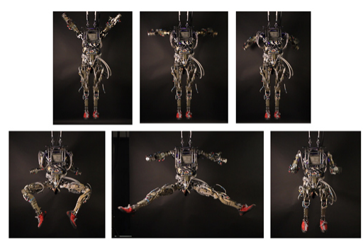The most original version of a military robot may be a four wheeled one or with four legs crawling on the ground. The continuous research and development process has however altered this initial property of an armed machine and created a more human-like robot to be used in wars. An example is the humanoid robot called Atlas which is developed by Boston Dynamics and funded by the DARPA in 2013. Operating with two legs, two arms and a head Atlas is able to function like a human, walking step by step and moving nimbly with great balanced body coordination. Another example is the US Army’s Petman which is an earlier version of Atlas. It’s also a humanoid robot with natural agile movement given as its capability to test chemical protection clothing. This testing function assigned to Petman allows it to perform some dangerous tasks that would be done by human otherwise.

Eventually with the desirable values of efficiency and safe provided by the robots, it is not surprising to picture an upward inclination in the robotic spending field among various industries as shown in the chart below:

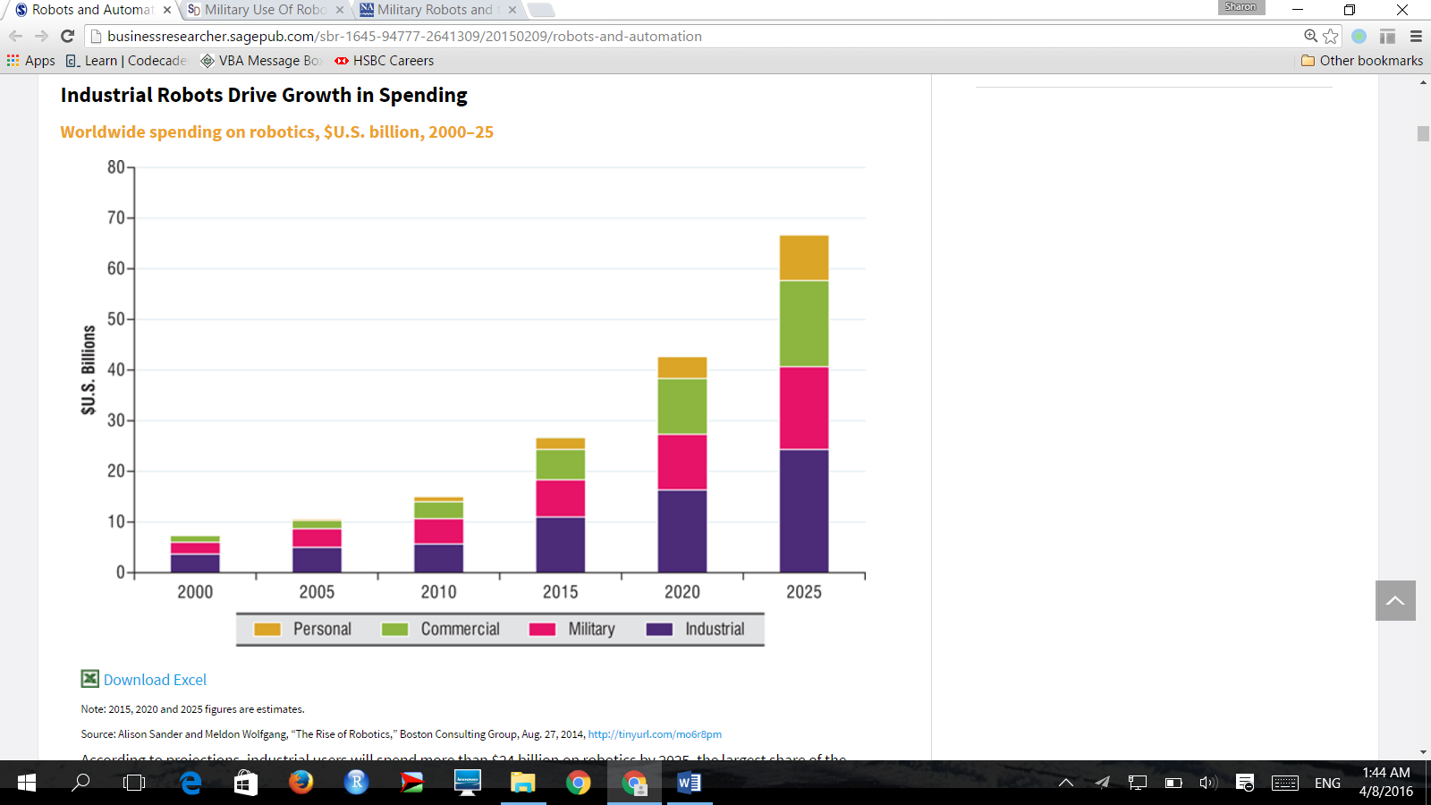

Note: 2015, 2020 and 2025 figures are estimates.

Source: Boston Consulting Group, 2014

**Army Situation in the US**

For many years the United States has been the leading country in military expenditure, spending almost US$600 billion which is nearly 4 times of that of China the second largest country in armed expenses according to the International Institute for Strategic Studies. Being the global giant in armed forces the US Army Training and Doctrine Command mentioned that the size of brigade combat team has been shrunk from 4,000 soldiers to 3,000 with the gap taking over by robots. This phenomenon has suggested a climbing trend in substituting humans with robots for the sake of safeguarding people’s life and reducing the harms brought to the warriors by battles.

Even in the recent cases of the US fights against Iraq and Afghanistan robots are increasingly replacing soldiers’ duties and it is told that around 30% of the US army to be robotic by 2020. With more and more capital being invested in the unmanned machines as shown in the following diagram (manned funding was decreased by 30 percentage point VS unmanned funding was increased by 27 percentage point),

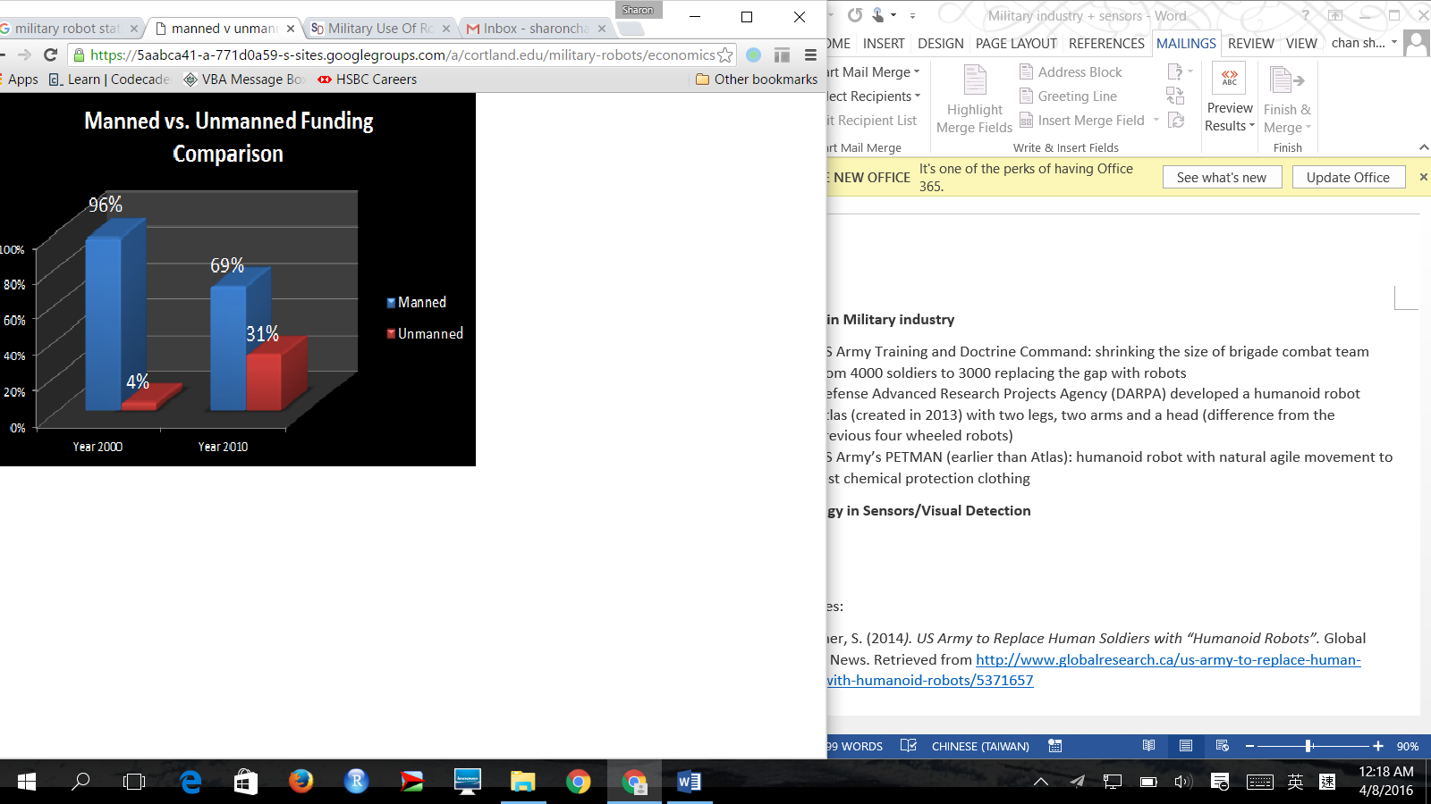  
Source: Benard Microsystems Limited, 2010

a growing demand for robots is expected which can eventually expand the scale of robotic research work and probably achieve economies of scale in robots’ manufacturing.

References:

1. Christopher, S. (March 3, 2014*). US Army to Replace Human Soldiers with “Humanoid Robots”.* Global Research News. Retrieved from <http://www.globalresearch.ca/us-army-to-replace-human-soldiers-with-humanoid-robots/5371657>
2. N.A. (2010). *Manned vs. Unmanned Funding Comparison.* Benard Microsystems Limited. Retrieved on October 5, 2011 from   
   <http://www.barnardmicrosystems.com/L4E_uav_market.html>
3. Singer, P. W. [Ted Talk]. (2009). *Military robots and the future of war*. [Video file]. Retrieved from <https://www.ted.com/talks/pw_singer_on_robots_of_war/transcript?language=en>
4. Alison, S. and Meldon, W. (August 27, 2014). *The Rise of Robotics*. Boston Consulting Group. Retrieved from <https://www.bcgperspectives.com/content/articles/business_unit_strategy_innovation_rise_of_robotics/>
5. N.A. (August 5, 2008). *Military Use of Robots Increases.* St Louis: Washington University. Retrieved from <https://www.sciencedaily.com/releases/2008/08/080804190711.htm>
6. Singer, P.W. (2009). *Military Robots and the Laws of War*. The New Atlantis. No. 23, pp. 25-45
7. The International Institute for Strategic Studies. (February 9, 2016). The Military Balance 2016: *The Annual Assessment of Global Military Capabilities and Defence Economics*. ISBN: 9781857438352. Retrieved from <https://www.iiss.org/en/publications/military%20balance/issues/the-military-balance-2016-d6c9>